#include<iostream>
using namespace std;
class Complex{
public:
double real;
double imag;
Complex(double r =0,double i=0)
{
real=r; imag=i;
}
};
Complex operator*(Complex co1,Complex co2)
{
Complex temp;
temp.real = co1.real * co2.real-co1.imag*co2.imag;
temp.imag = co1.real * co2.imag+co1.imag*co2.real;
return temp;
}
int main()
{
Complex com1(1,2),com2(3,4),total1,total2;
total1 = operator*(com1,com2);
cout<<"real1="<<total1.real<<" "<<"imag1="<<total1.imag<<endl;
total2 = com1 * com2;
cout<<"real2="<<total2.real<<" "<<"imag2="<<total2.imag<<endl;

return 0;
}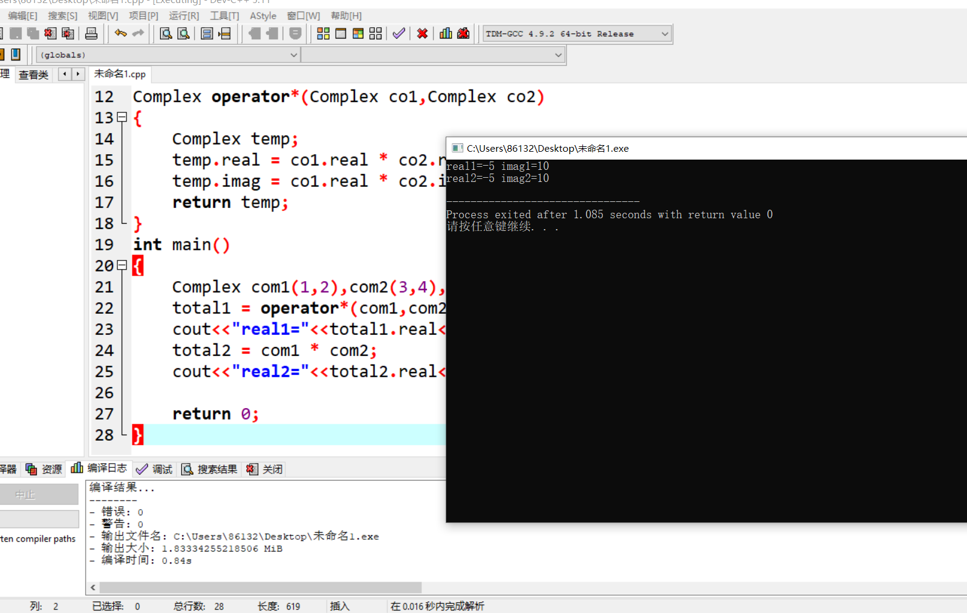

心得
第七次上机，我根据函数多态性的要求，分别尝试了类外定义运算符重载函数、友元运算符重载函数和成员运算符重载函数，实现了对两个复数进行加法和乘法。

Copyright © 2021-2099 BoYang. All rights reserved.

